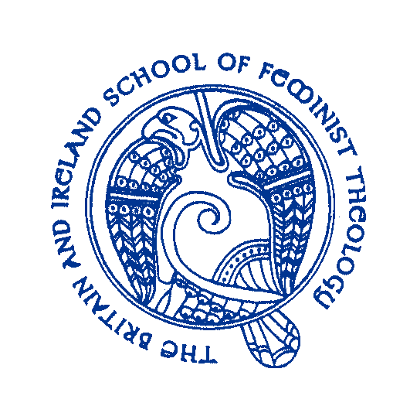
BRITAIN AND IRELAND SCHOOL OF FEMINIST THEOLOGY
SUMMER SCHOOL 2020
Tuesday 16th June to Thursday 18th June 2020
At University of Wales, Trinity St David, Lampeter, SA48 7ED
Ecofeminist Theologies In the Age of Climate Crisis.
Our keynote speakers are: Prof Heather Eaton, [St Paul, University, Ottawa], Prof Agnes Brazal, [DeLa Salle University, Manila], Prof Catherine Keller, [Drew University, USA], Kara Moses [Re-Wilding, Cymru]. Dr Megan Clay will discuss the art exhibition entitled ‘Women Dancing with Gaia’.
Cost: £190 inclusive of B&B, lunch, evening meal, teas and coffees throughout the day and conference fee. All meals will be vegetarian
Daily Rates: Full days £60 including lunch; Half Days £30
Early Bird Booking before 15th April, £175.
Closing date for all bookings 30th May 2020.
If you offer a seminar paper or workshop there is a £40 fee discount for full board participants and £10 fee discount for daily participants. All papers will be considered for publication in the international journal ‘Feminist Theology’.
For further information contact: Professor Lisa Isherwood mailto:lisherwood@uwtsd.ac.uk
…………………………………………………………………………………………………………………………………………………………….
Booking Form: [Please return this form whatever payment method you use]
Name
Address
E-Mail
Full Attendance Tuesday only Thursday Only
Food Allergies……………………………………………………………………….
Payment by cheque to BISFT, The Lodge, Cook Rees Ave, Neath SA!! 1JT or by BACS transfer Britain & Ireland School of Feminist Theology Sort Code 16-2464 Account 11265608. Your name as reference.

